Can Reinforcement Learning effectively detect money laundering, and how does it compare to leading supervised learning methods on synthetic transaction data?
Kaan Gogcay
Hogeschool van Amsterdam
May 11, 2026

Abstract
mijn abstract is nog outdated van de pva Money laundering is a significant global problem, with an estimated 16 billion euros laundered annually in the Netherlands alone. While machine learning has been widely adopted for Anti-Money Laundering (AML) transaction monitoring, the application of Reinforcement Learning (RL) to this domain remains largely unexplored. Existing RL approaches either rely on graph-based methods not applicable to traditional banking data, or target credit card fraud specifically rather than money laundering. This research investigates whether a Deep Q-Network (DQN) can effectively detect money laundering on tabular banking transaction data, and how it compares to XGBoost, the current industry and academic standard. The SAML-D dataset, a synthetic AML dataset developed in consultation with AML specialists, is used for training and evaluation. Both models are evaluated using the Area Under the PrecisionRecall Curve (AUPRC), consistent with industry practice at ING and ABN AMRO, and SHAP values are applied to interpret model decisions in accordance with the explainability requirement imposed by the Dutch Anti-Money Laundering Act (Wwft). The research follows an experimental design with a chronological 70/15/15 train/validation/test split to prevent data leakage. This work contributes to the literature by being the first to apply pure Reinforcement Learning to AML detection on tabular banking transaction data, with legally required explainability incorporated into the proposed model.

Introduction
This chapter introduces the problem of money laundering, reviews the current state of the art, and identifies the research gap that motivates this work.

Context Analysis
To understand the problem this research addresses, this section introduces money laundering, its detection, and the limitations of traditional approaches.

Money Laundering
Money laundering is the process of concealing the illegal origin of funds to make them appear legitimate, allowing criminals to use the proceeds in the legal economy FIU-the Netherlands (2023); Financial Crimes Enforcement Network (FinCEN) (nd). The scale of this problem is significant: The Netherlands alone sees an estimated 16 billion euros laundered annually, ranking eighth globally in terms of laundered funds Menon and Nguyen (2026). To combat this, financial institutions in the Netherlands are legally required to monitor and report suspicious transactions under the Wet ter voorkoming van witwassen en financieren van terrorisme (Wwft) Ministerie van Financi¨en (2008). These funds often come from crimes such as drug trafficking, fraud, illegal pornography, tax evasion, robbery, blackmail, bribery, piracy, people trafficking and many more malicious activities FIU-the Netherlands (2023); Cox (2012); Menon and Nguyen (2026). Once obtained, the money cannot be spent freely, so criminals must disguise its illegal origin. This is achieved through the money-laundering process, which typically occurs in three stages: placement, layering and integration Cox (2012).
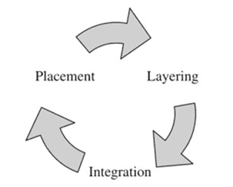
Figure 1: The money-laundering process
Placement Placement is the first step in the laundering process. In this step, criminals attempt to introduce their funds into the financial system. This is often associated with depositing cash into bank accounts, but placement is not limited to plain deposits. Some examples of introducing criminal money to the financial system cover: purchasing paintings, antiques and boats Cox (2012).
Layering Once criminally earned funds have been introduced to the financial system, criminals try to hide the origin of this money. This can be done in various ways, such as investing in legitimate assets, buying and selling collectibles, or making multiple smaller transactions across different accounts. The more these funds are moved back and forth, the harder it becomes to trace their original source Cox (2012).
Integration Once the origin of illegal funds is difficult to trace, criminals can freely integrate their laundered money into the economy. This can be done by investing in businesses, purchasing property, buying jewellery, or other assets that appear legitimate Cox (2012).

Money Laundering Detection
Money laundering detection or AML (anti-money laundering) refers to the process of detecting money laundering. AML technology has changed significantly over the past years. Evolving from dedicated AML teams to rule-based systems to semi-automated machine learning workflows Weber et al. (2018).

Traditional AML Methods and its Limitations
Rule-based systems, the traditional approach to AML, became one of the first forms of automated detection and are still used in current day Attard and de Bruijn (2026); Menon and Nguyen (2026). These systems typically monitor transactions and generated alerts for activity exceeding thresholds, such as amounts over $10,000, amounts just below $10,000, or multiple smaller transactions within 24 hours that collectively surpassed $10,000 Weber et al. (2018). Over time, banks have expanded the amount of rules in their systems, in attempt to catch as many suspicious transactions as possible. ING, a major bank in the Netherlands, reported using close to 500 rules as of March 2026 Attard and de Bruijn (2026). While rule-based systems improved efficiency, they had limitations in handling complex laundering patterns and large-scale data, which led to the adoption of machine learning Menon and Nguyen (2026).

Literature Overview

State of the Art
This section provides an overview of the current state-of-the-art regarding Machine Learning applications within Anti-Money Laundering. The field is currently dominated by supervised learning methods, particularly tree-based ensemble approaches, as evidenced by both academic literature and industry benchmarks.
IEEE-CIS Fraud Detection Competition In 2019, Kaggle hosted the IEEE-CIS Fraud Detection Competition in collaboration with Vesta Corporation, an event that remains a foundational milestone for machine learning in the financial sector IEEE Computational Intelligence Society (2019). By providing a massive, real-world dataset directly from Vesta’s e-commerce transactions, the competition set a definitive benchmark for the state-of-the-art in transaction monitoring and fraud detection algorithms.
Vesta, a leader in e-commerce payment solutions, shared this data to challenge researchers to improve the effectiveness of fraudulent transaction alerts. The competition consisted of two main goals: to increase the detection of criminal activity while minimizing the ”false positives” that lead to legitimate customers having their cards declined at the checkout.
The competition allowed researchers to join individually or in teams, with the flexibility to submit an unlimited number of solutions to refine their results. The scale of the competition is reflected in the final statistics: 7,389 individual researchers, 6,351 unique teams, 125,219 submissions and a $20,000 prize pool.
The competition results provide a clear map of what defines as the ”state-of-the-art” for tabular fraud data. An analysis of the top-performing teams (which shared their solution) reveals a heavy reliance on supervised learning, specifically Gradient Boosting Decision Trees (GBDT):
- 1st Place (Score: 0.9677): The winning solution utilized a stacked ensemble of CatBoost, XGBoost, and LightGBM. The team also developed a Neural Network, but it was dropped from the final submission because it underperformed compared to the Gradient Boosting models Deotte and Yakovlev (2019).
- 2nd Place (Score: 0.9672): This team achieved their ranking using a blend of LightGBM, CatBoost, and XGBoost. Their performance was further boosted by a temporal post-processing step that overrode predictions based on a user’s past fraud history Bryansky et al. (2019).
- 5th Place (Score: 0.9424): The 5th place solution relied on a simple average of four independent LightGBM models. They also created a specialized model focused on ”single transaction” users, the output of which was used as a feature for their main LightGBM ensemble Team Lions
(2019).
Recent developements within Supervised Learning A recent survey (2017–2023) analysed papers that cover supervised AML models trained on real-world financial data, summarizing results across studies into a comparative overview Youssef et al. (2023).
As shown in [Table 1, Youssef et al. (2023)], the most frequent used supervised methods in this time period are Logistic Regression (6 studies), Random Forest (5), XGBoost (4), Decision Tree (3) and Support Vector Machines (3). The table also indicates what models have been rarely explored recently (only once) on real banking data, also including non-supervised methods, namely: Artificial Neural Networks, Gru, LSTM, Transformers, Decision Regression Tree, Naive Bayes, K-Nearest Neighbors, Feedforward Network, AdaBoost, Graph Deep Learning and Graph Convolutional Network. It is worth noting that the last three of these rarer methods were only applied to cryptocurrency transaction datasets rather than traditional banking data, leaving their potential on traditional banking data unexplored.

Reinforcement Learning, an Emerging Method
To date, Reinforcement Learning has barely been explored within AML.
One paper proposes FraudGNN-RL Cui et al. (2025), which combines GNNs with RL for adaptive fraud detection. Transactions are modeled as a dynamic graph and a Deep Q-Network dynamically adjusts the detection threshold to adapt to evolving fraud patterns. Experiments on a real-world dataset achieved a 97.3% F1-score and 31% fewer false positives compared to baselines including XGBoost, GCN, and several other methods.
Another paper Qayoom et al. (2024) also explores RL utilizing a Deep Q-Network, but without the use of graph-based methods. The model was trained and tested on a publicly available Kaggle credit card fraud dataset, achieving 97.1% validation accuracy. It is worth noting that this paper focuses on credit card fraud rather than money laundering specifically, though both problems are fundamentally based on transaction monitoring.

Stakeholder Insights
To ground this research in real-world practice, presentations were attended from data scientists at two major Dutch banks: ING Attard and de Bruijn (2026) and ABN AMRO Menon and Nguyen (2026).

ING
ING uses a workflow including a rule-based system and a human-in-the-loop to generate labels for the supervised models Attard and de Bruijn (2026). ING currently operates approximately 500 static rules to flag potentially suspicious transactions. When a rule fires, a human investigator reviews the transaction and determines whether it is genuinely suspicious. This judgment then becomes the label. This labeling process is therefore inherently dependent on both the quality of the existing rules and human judgment.
ING exclusively uses supervised classification models for transaction monitoring. Tree-based models, particularly XGBoost, being the preferred approach due to their strong performance and explainability. The data scientists would like to explore more complex models such as neural networks and graph-based approaches but face practical barriers, including engineering constraints given the scale of the data (approximately 8 billion transactions) and the difficulty of obtaining regulatory sign-off for less interpretable models. Explainability is a must and is therefore not negotiatable. Also worthy to mention is that the compliance team does not permit training on synthetic data.
Given that potential financial crime represents only 1–2% of all transactions, the data is highly imbalanced. Rather than addressing this through resampling, ING uses the Area Under the PrecisionRecall Curve (AUPRC) as their primary evaluation metric, a measure well suited to imbalanced data, targeting a minimum recall of 0.95. Accuracy is explicitly avoided as a standalone metric as it would be misleading under such class imbalance.

ABN AMRO
ABN AMRO takes a broader approach than ING, combining both supervised and unsupervised models within their transaction monitoring pipeline Menon and Nguyen (2026). Each transaction passes through two parallel flows: one using supervised models, including XGBoost, decision trees, and random forests, to detect known money laundering patterns, and another using unsupervised models, including auto-encoders, clustering, and isolation forest, to detect unknown or anomalous behaviour. Both flows feed into manual review by investigators before anything is reported to the FIU.
Similar to ING, labels at ABN AMRO originate from rule-based systems, a process they acknowledge is error-prone. They expressed a desire to move towards ML-based labelling in the future.
A notable practice at ABN AMRO is their operational use of SHAP values. Every alert generated by the model is accompanied by a ranked list of the top three features that contributed to the alert, along with a non-technical explanation for investigators. This confirms that SHAP is not only theoretically suitable for AML explainability but is already used in production at a major Dutch bank.
Similar to ING, ABN AMRO uses AUPRC as their primary evaluation metric. The detection threshold is not fixed by the data scientists alone. It is determined in consultation with business stakeholders, balancing the desire to catch as many cases as possible against the number of alerts investigators can realistically review.

Comparison
Both banks confirm that tree-based models, particularly XGBoost, represent the current state of the art in production AML systems, being consistent with the literature. Both face the same fundamental labelling challenge, where ground truth is derived from rule-based systems rather than verified financial crime cases. The key difference is that ABN AMRO combines supervised and unsupervised approaches, while ING relies exclusively on supervised models. Both banks use AUPRC as their primary metric, which sets the evaluation strategy of this research.

Identified Gap
Despite the promise of Reinforcement Learning in adaptive fraud detection, its application to AML on tabular transaction data remains largely unexplored. The literature reveals several concrete gaps.
First, graph-based methods such as Graph Convolutional Networks and Graph Deep Learning, which are well suited to the relational nature of banking transactions, have only been applied to cryptocurrency datasets such as the Elliptic dataset Alarab et al. (2020); Weber et al. (2019). Their potential on traditional banking transaction data remains unexplored.
Second, while Reinforcement Learning has shown promise in fraud-specific transaction monitoring, existing RL approaches have not been applied to AML transaction monitoring, where the goal is to detect a wide range of laundering patterns rather than detecting only fraud. FraudGNN-RL combines GNN with RL but was evaluated on a general fraud dataset rather than a dedicated AML dataset Cui et al. (2025). The only pure RL approach found in the literature targets credit card fraud, which, while related, is a fundamentally different problem from money laundering Qayoom et al. (2024).
Taken together, these gaps point to a clear research opportunity: applying Reinforcement Learning to AML on tabular transaction data, without relying on graph structure that may not be available in practice.

Research Question
Based on the identified gap, this research investigates the following main question:
Can Reinforcement Learning effectively detect money laundering, and how does it compare to leading supervised learning methods on transaction data?
To answer this, the following subquestions are addressed:
- How can Reinforcement Learning be applied to AML transaction monitoring?
- How does Reinforcement Learning perform compared to leading supervised learning methods?
- What are the benefits and limitations of Reinforcement Learning for AML?

Scope
This research focuses on applying Reinforcement Learning to AML transaction monitoring using tabular data. Although the literature highlights graph-based methods such as GCN and Graph Deep Learning as promising directions, these are explicitly out of scope.
Since the context of this research involves banking institutions as stakeholders, it may be assumed that real banking data is used. This is not the case. Real-world AML datasets are not publicly available due to privacy and legal constraints, making synthetic datasets the only viable option. Cryptocurrency transaction datasets are out of scope.
Furthermore, while the RL papers discussed in the literature review originate from the broader fraud detection domain, this research is scoped specifically to money laundering detection. Credit card fraud and other forms of financial fraud are related but distinct problems and are not the subject of this research.
Finally, given that the Wwft requires financial institutions to be able to explain AML decisions, explainability of the RL model is addressed in this research Ministerie van Financi¨en (2008). However, a full legal compliance audit is out of scope. The explainability analysis serves to assess whether the model’s decisions can be interpreted in a meaningful way, not to provide a legal judgment on its deployability.

Background
This chapter provides the theoretical and ethical foundation for this research, building on the identified gap by covering the techniques used, a comparison of related work, and the considerations that shaped the research design.

Relevant Literature on Techniques

Reinforcement Learning and Deep Q-Networks
Reinforcement Learning (RL) is a machine learning paradigm in which an agent learns to make decisions by interacting with an environment. Rather than learning from a labeled dataset, the agent receives a reward or penalty based on its actions and uses this feedback to improve its policy over time. This makes RL particularly suitable for sequential decision-making problems where the optimal action depends on context and may change over time. A widely used RL algorithm is the Deep QNetwork (DQN), which combines Q-learning with a neural network to approximate the value of taking a given action in a given state. DQN has been successfully applied to transaction monitoring in recent literature. Cui et al. (2025) use DQN to dynamically adjust fraud detection thresholds and feature importance weights across a graph of interconnected financial entities, evaluating their approach across mobile money, credit card, and e-commerce transaction domains. Qayoom et al. (2024), by contrast, narrow their scope to credit card fraud specifically, where the agent learns to flag transactions that deviate from an individual cardholder’s recent spending behaviour. Together, these works establish DQN as the most prominent RL approach in this domain and a natural starting point for this research.

Explainability with SHAP
SHAP (SHapley Additive exPlanations) is an explainability method that can be applied to any machine learning model, assigning each input feature a contribution score for a given prediction. This makes it particularly suitable for interpreting black-box models such as the Deep Q-Network used in this research. In the context of AML, SHAP has already been applied in Tertychnyi et al. (2022) (also discussed in the survey by Youssef et al. (2023)) and by ABN AMRO Menon and Nguyen (2026) to identify which features contributed most to a model flagging a customer as high-risk. Given the explainability requirements imposed by the Wwft, SHAP will be used in this research to interpret the decisions made by the RL model.

Related Work Comparison
As established in the literature overview, only two papers were found that apply Reinforcement Learning to transaction monitoring. Table 1 provides a structured comparison between these papers and the research proposed in this thesis.
Table 1: Comparison of related work
 | Cui et al. Cui et al. (2025) | Qayoom et al. Qayoom et al. (2024) | This research
Method | GNN + RL | RL only | RL only
Domain | General fraud | Credit card fraud | AML
Data | PaySim, Credit Card 2023, IEEE-CIS | ULB Credit Card Fraud | SAML-D
Metrics | AUC-ROC, AUPRC, F1, Recall@k% | Accuracy and loss | AUPRC
Explainability | - | - | SHAP
The comparison highlights that while both related papers apply Reinforcement Learning to transaction monitoring, neither targets money laundering specifically. FraudGNN-RL relies on graph structure that may not be available in traditional banking environments, while Qayoom et al. focus on credit card fraud, which is a fundamentally different problem from money laundering.
A notable methodological concern with Qayoom et al. is their exclusive use of accuracy and loss as evaluation metrics. Given that their dataset is highly imbalanced (with only 0.172% fraudulent transactions) accuracy alone is a misleading indicator of model performance. A model that classifies every transaction as legitimate would still achieve over 99% accuracy. Metrics such as AUC-ROC, AUPRC, precision, recall, and F1-score are better suited for imbalanced fraud detection tasks, as used by FraudGNN-RL. This research will therefore adopt AUPRC as its evaluation metric, consistent with industry practice at both ING and ABN AMRO Attard and de Bruijn (2026); Menon and Nguyen
(2026).

AI Suitability Justification
The suitability of AI for AML transaction monitoring is supported by both the literature and insights gathered from presentations by data scientists at ING Attard and de Bruijn (2026) and ABN AMRO Menon and Nguyen (2026).
The fundamental limitation of rule-based systems is that they assume the programmer has a complete picture of all criminal patterns. As ABN AMRO noted, laundering patterns are too diverse and dynamic for rules to cover every scenario; at some point, the number of rules simply becomes unmanageable Menon and Nguyen (2026). ING’s reported use of approximately 500 static rules proves this problem in practice Attard and de Bruijn (2026). Machine learning addresses this by learning complex patterns directly from data, allowing the system to detect suspicious behaviour without relying on predefined thresholds.
A further argument for AI is the nature of money laundering itself. As ABN AMRO observed, individual transactions may not appear suspicious by itself, it is the patterns across transactions that reveal criminal activity Menon and Nguyen (2026). Machine learning models are well suited to capture these patterns, particularly at the layering stage of the laundering process, which is both the most difficult stage for rules to catch and the most suitable to model-based detection Menon and Nguyen (2026).
Both banks also confirmed that tree-based models, particularly XGBoost, currently outperform more complex alternatives in practice, not because simpler models are theoretically superior, but because they offer the best trade-off between performance and explainability given regulatory constraints Attard and de Bruijn (2026); Menon and Nguyen (2026). This confirms that AI is not only suitable for AML but is already the industry standard, while also highlighting that any proposed model must remain interpretable to satisfy regulators.

Ethical and Societal Considerations
The application of machine learning to AML transaction monitoring raises several ethical and societal considerations that are relevant to this research.

Societal Impact
Money laundering has a significant societal cost. ABN AMRO estimated that approximately 16 billion euros is laundered in the Netherlands annually, placing the country eighth globally in terms of laundered funds Menon and Nguyen (2026). Effective AML detection therefore has a direct positive impact on society by disrupting criminal activity and protecting the integrity of the financial system.

False Positives and Customer Impact
A key ethical concern in AML systems is the consequences of false positives. When a legitimate customer is incorrectly flagged as suspicious, they may face restricted access to banking services, delayed transactions, or reputational harm. Both ING and ABN AMRO explicitly aim to reduce false positives in their systems Attard and de Bruijn (2026); Menon and Nguyen (2026). This research adopts the same objective by optimizing on AUPRC, which balances precision and recall.

Bias and Fairness
Machine learning models trained on historical transaction data risk inheriting biases present in that data. For example, if certain demographic groups or transaction types were historically flagged more often, a model may learn to replicate these patterns. ING acknowledged the existence of dedicated teams for bias and fairness assessment Attard and de Bruijn (2026), reflecting the seriousness of this concern.

Labeling Bias
A subtler but important issue is that the labels used to train supervised AML models are themselves derived from rule-based systems and human investigators. As both banks acknowledged, this process is error-prone Attard and de Bruijn (2026); Menon and Nguyen (2026). A model trained on these labels may therefore learn to replicate the limitations and biases of the existing system rather than detecting true financial crime. This is a fundamental challenge in AML that this research inherits and acknowledges as a limitation.

Explainability as an Ethical Requirement
Explainability is not only a legal requirement under the Wwft Ministerie van Financi¨en (2008) but also an ethical one. When a model flags a customer as suspicious, investigators and potentially customers themselves deserve to understand why. ABN AMRO’s operational use of SHAP values to provide investigators with a ranked explanation of each alert reflects this principle in practice Menon and Nguyen (2026). This research adopts the same approach by incorporating SHAP-based explainability into the proposed model.

Data Privacy
The use of personal financial data raises privacy concerns. In the Netherlands, the GDPR (known locally as the AVG) restricts what personal data can be used for model training European Parliament and Council of the European Union (2016). ING noted that sensitive attributes such as name, address, gender, nationality, and country of origin are not accessible for model training Attard and de Bruijn (2026). This research addresses privacy concerns by relying exclusively on publicly available, anonymized datasets rather than real customer data.

Research Design
This chapter describes how the research was structured, including the experimental design, the type of study, the baseline model, and the logic used to compare both models.

Research Design
This research followed an experimental design in which a Reinforcement Learning model and a supervised learning baseline were implemented, trained, and evaluated on the same AML dataset. The research proceeded in four phases. First, a suitable publicly available AML dataset was selected and preprocessed. Second, a baseline supervised model was implemented based on the current state of the art in both the literature and industry practice. Third, a Deep Q-Network was implemented and applied to the same AML detection task. Finally, both models were evaluated using the same metrics and validation strategy, and their results were compared to answer the main research question.

Type of Study
This research is an empirical, experimental study involving the construction and evaluation of machine learning models on financial data. This approach was necessary because, as established in the literature overview, RL had not previously been applied to AML on tabular banking data.

Baseline Definition
The baseline model is XGBoost, an extreme gradient boosting algorithm. This choice is justified on three grounds. First, the academic literature consistently identifies XGBoost as one of the most frequently used methods in AML, appearing in four of the studies surveyed by Youssef et al. (2023). Second, the top-performing teams in the IEEE-CIS Fraud Detection Competition IEEE Computational Intelligence Society (2019) relied heavily on XGBoost as part of their winning solutions Deotte and Yakovlev (2019); Bryansky et al. (2019); Team Lions (2019), establishing it as the state of the art for tabular fraud detection. Third, both ING and ABN AMRO confirmed in their presentations that XGBoost is their primary model in production Attard and de Bruijn (2026); Menon and Nguyen (2026). Using XGBoost as the baseline therefore ensured that the RL model was benchmarked against a method that is both academically established and practically relevant.

Comparison Logic
Both the supervised baseline (XGBoost) and the reinforcement learning model (DQN) were trained and evaluated on the same dataset, using the same chronological train-validation-test split to ensure a fair comparison. The primary evaluation metric is AUPRC, consistent with industry practice at ING and ABN AMRO Attard and de Bruijn (2026); Menon and Nguyen (2026). AUPRC is particularly suitable for imbalanced datasets, where money laundering cases represent only a small fraction of all transactions. A model was considered to outperform the baseline if it achieved a higher AUPRC score under the same experimental conditions.

Requirements
This chapter defines the legal, functional, and technical requirements that shape the design and evaluation of the proposed model.

Legal & Ethical Requirements
This research operates within the Dutch legal framework for financial crime detection and data privacy. This highlights two particular laws: Wet ter voorkoming van witwassen en financieren van terrorisme (Wwft), the Dutch implementation of the EU Anti-Money Laundering Directive Ministerie van Financi¨en (2008) and General Data Protection Regulation (GDPR), known locally as Algemene Verordening Gegevensbescherming (AVG) European Parliament and Council of the European Union
(2016).
Table 2: Legal & Ethical Requirements
ID | Requirement | Source
LERQ1 | When a transaction is flagged as suspicious, the model must be able to explain why. | Wwft,  16.2e | Art.  Ministerie
 |  | van  (2008) | Financi¨en
LERQ2 | The use of the following personal attributes is explicitly prohibited in model training: race, ethnic background, political opinion, religious or philosophical beliefs, trade union membership, genetic data, biometric data, health data, and data concerning a natural person’s sexual behaviour or sexual orientation. | GDPR, Art. 9.1 European Parliament and Council of the European Union  (2016)

Functional Requirements
The following functional requirements define what the model must be capable of doing:
Table 3: Functional Requirements
ID | Requirement | Source
FR1 | The model must classify transactions as either suspicious or legitimate. | Research scope
FR2 | The model must output a continuous suspiciousness score per transaction. | Required for AUPRC, Industry practice Attard and de Bruijn  (2026)
FR3 | The model must provide a feature-level explanation for each flagged transaction using SHAP values. | Wwft, Art. 16.2e Ministerie van Financi¨en (2008);
FR4 | The model must be evaluated using AUPRC as the primary metric. | Industry practice Attard and de Bruijn (2026); Menon and  Nguyen (2026)
FR5 | Both the RL model and the XGBoost baseline must be trained and evaluated on the same dataset under the same conditions to ensure a fair comparison. | Research scope

Technical Requirements
The following technical requirements define how and in what circumstances the model must be built:
Table 4: Technical Requirements
ID | Requirement | Source
TR1 | The dataset must be tabular | Research scope
TR2 | The dataset must be anonymized, containing no personal identifiers. | GDPR, Art. 9.1 European Parliament and Council of the European Union (2016)
TR3 | The dataset must not contain cryptocurrency transactions. | Research Scope
TR4 | A Deep Q-Network architecture must be used for the  RL-model | Related Work Cui et al. (2025); Qayoom et al. (2024)
TR5 | The baseline model must be implemented using XGBoost. | Literature Youssef et al. (2023) and Industry practice Attard and de Bruijn (2026); Menon and Nguyen  (2026)

Data
This chapter describes the dataset selected for this research, its characteristics, the preprocessing steps applied, and the risks and biases associated with its use.

Data Sources
Real-world AML datasets are not publicly available due to privacy and legal constraints Jensen et al. (2023), making synthetic datasets the only viable option for this research. Multiple synthetic datasets were considered, as shown in Table 5. Note that IBM AML appears six times in the table since it provides six variations of its dataset Altman (2019). It is also worth noting that the IBM datasets, SAML-D and money laundering data provide a data generator, meaning that if the data volume or class imbalance of the existing dataset is not suitable, additional data can be generated as needed Oztas et al. (2023); Mahootiha (2023).
From a representativeness perspective, SynthAML would have been the most suitable dataset for this research. It is the only dataset grounded in real EU banking data, having been synthesized from actual transactions at Spar Nord, a Danish bank operating under the same EU regulatory framework as Dutch banks Jensen et al. (2023). However, SynthAML does not include a data generator and contains only 20,000 transactions, which is insufficient for training deep learning models such as a DQN.
The remaining viable options are IBM AML and SAML-D, neither of which is specifically representative of the Dutch or EU banking context. Between these two, SAML-D was selected because it includes the Laundering type field, which is absent from IBM AML. This field labels not only whether a transaction is suspicious, but also which laundering pattern it belongs to, such as smurfing or over-invoicing. This enables a more granular evaluation of model performance per pattern type, and during stakeholder evaluation allows investigators to assess whether the model detects specific schemes differently.
Table 5: AML Dataset Comparison
Dataset | Rows | Features | Type | Labels | % fraud | Data Generator | Kaggle Score
IBM AML (HI-Large) | 180M | 11 | Synthetic | Yes | 0.125% | Yes | 9.41
IBM AML (HI-Medium) | 32M | 11 | Synthetic | Yes | 0.110% | Yes | 9.41
IBM AML (HI-Small) | 5M | 11 | Synthetic | Yes | 0.100% | Yes | 9.41
IBM AML (LI-Large) | 176M | 11 | Synthetic | Yes | 0.057% | Yes | 9.41
IBM AML (LI-Medium) | 31M | 11 | Synthetic | Yes | 0.050% | Yes | 9.41
IBM AML (LI-Small) | 7M | 11 | Synthetic | Yes | 0.051% | Yes | 9.41
SAML-D | 9.5M | 12 | Synthetic | Yes | 0.104% | Yes | 10.00
SynthAML | 20,000 | 2 | Synthetic | Yes | 17.175% | No | N/A
money laundering data | 2,340 | 7 | Synthetic | Yes | 59.786% | Yes | 7.65

Data Characteristics
The SAML-D dataset Oztas et al. (2023) is a tabular dataset consisting of 9,504,852 transactions across 12 features, stored in CSV format. The target column Is laundering is a binary indicator distinguishing normal from suspicious transactions.

Features
The dataset contains the following features, divided into transaction features and label features:
Table 6: SAML-D Feature Overview
Category | Feature | Description
Transaction Features | Time | Time of transaction (hh:mm:ss)
 | Date | Date of transaction (yy-mm-dd)
 | Sender account | Sender bank account ID
 | Receiver account | Receiver bank account ID
 | Amount | Transaction amount (decimal)
 | Payment type | Payment type (e.g. Cash Deposit, Cheque)
 | Payment currency | Sender account currency (e.g. UK Pounds, Euro)
 | Received currency | Receiver account currency (e.g. UK Pounds, Euro)
 | Sender bank location | Sender bank location (e.g. UK, Spain)
 | Receiver bank location | Receiver bank location (e.g. UK, Spain)
Label Features | Is laundering | Binary indicator of laundering activity
 | Laundering type | Type of laundering pattern (e.g. Smurfing, Over-  Invoicing)

Class Imbalance
The dataset is highly imbalanced, with only 0.104% of transactions labelled as laundering. This reflects the nature of real-world AML data, where fraudulent activity represents a small fraction of all transactions. To account for this imbalance during model evaluation, AUPRC was used as the primary metric Attard and de Bruijn (2026); Menon and Nguyen (2026), as it evaluates performance specifically on the minority class across all classification thresholds.

Train/Test Split
The dataset was split chronologically into a training set (70%), validation set (15%), and test set (15%), inspired by the 70/30 split used by FraudGNN-RL Cui et al. (2025), with the held-out 30% divided equally between validation and test to allow for hyperparameter tuning without leaking the final evaluation set. The chronological split ensured the model was always trained on past transactions and evaluated on future ones, preventing data leakage and reflecting real-world deployment conditions where a model must generalize to transactions it has never seen before.

Preprocessing
Before training, several preprocessing steps were applied to prepare the dataset for both models.
Feature engineering. For each bank account in the training set, a statistical profile was constructed from its transaction history. These profiles were then joined onto the validation and test sets by account ID, ensuring no data leakage. This approach follows Harris et al. (2021), who demonstrated that adding account-level aggregates improves money laundering detection performance. Accounts not seen during training received a value of 0 for all profile features, indicating no known history. The Laundering type column was excluded from the feature set as it would constitute label leakage, though it was retained in the saved splits for post-hoc per-pattern SHAP analysis.
The effect of feature engineering is illustrated below. Two transactions from the same sender account are shown before and after the engineered features are appended:
Table 7: Two transactions before feature engineering
Date | Time | Sender | Receiver | Amount | Payment type
2022-03-14 | 09:32:11 | 1 | 67 | 5,450 | Credit card
2022-03-14 | 11:15:44 | 1 | 203 | 6,100 | Credit card
Table 8: Same transactions after feature engineering (many features left out, see Table 9 for all features)
Date | Time | Sender | Receiver | Amount | Payment type | sender tx count | sender amount mean | sender unique receivers
2022-03-14 | 09:32:11 | 1 | 67 | 5,450 | Credit card | 847 | 1,243 | 312
2022-03-14 | 11:15:44 | 1 | 203 | 6,100 | Credit card | 847 | 1,243 | 312
Notice that both transactions share identical engineered feature values, because they originate from the same sender account. The profile reflects the account’s entire training history rather than the individual transaction. A transaction from an account with 847 prior transactions sending to 312 unique receivers tells a very different story than the raw amount alone.
The SAML-D dataset contains 28 transaction typologies (11 normal and 17 suspicious) each representing a distinct money laundering or normal banking pattern. The engineered features are designed to capture as many of these typologies as possible using static account-level statistics. Table 9 shows which suspicious patterns each feature group targets.
Table 9: Engineered feature groups and the suspicious patterns they target
Feature Group | Example Features |  |  |  | Suspicious Patterns Covered
Sender statistics | sender sender sender sender sender | tx coun amount amount amount amount |  | t, mean, std, min, max | Smurfing, Structuring, Single large, Behavioural Change
Sender diversity | sender sender sender | unique unique unique |  | receivers, currencies, locations | Fan Out, Layered Fan Out,  Over-Invoicing
Receiver statistics | receiver receiver receiver receiver receiver |  | tx count, amount mean, unique senders, unique currencies, unique locations |  | Fan In, Layered Fan In, Gather-  Scatter
Fan ratios | fan out ratio, fan in ratio |  |  |  | Bipartite, Stacked Bipartite,  Scatter-Gather
Cross-border flags | iscross currency, iscross border |  |  |  | Over-Invoicing, Lay-  ered Fan Out, Layered Fan In
Three suspicious typologies could not be captured by this feature set. Cycle requires graph traversal to detect money moving in a circular chain back to the origin account, which static account-level aggregates cannot capture. Deposit-Send and Cash Withdrawal both rely on detecting activity within a short time window, for example, whether an account deposited cash and sent it onwards within minutes. In principle, this could be tracked by storing the timestamp of the last deposit in the account profile. However, since profiles are built exclusively from the training set, any deposit occurring after the training cutoff is never recorded. By the time a validation or test transaction is scored, the stored timestamp may be months old, making a feature designed to detect activity within minutes effectively meaningless. These features were therefore not included in the final feature set. This problem is also referred to as the rolling time window.
Encoding. XGBoost handles categorical features natively as category types, requiring no encoding. The DQN, however, requires fully numeric input. Therefore, the five categorical features (payment type, payment currency, received currency, sender bank location, and receiver bank location) were one-hot encoded for the DQN, expanding the feature set from 26 to 90 features.
Scaling. XGBoost does not require scaling by design. The DQN, by contrast, is a neural network whose gradient updates are sensitive to feature scale. Features on very different scales can cause gradients to become unstable during training, leading to poor convergence. To prevent this, all numeric features were standardised using a StandardScaler fitted on the training set only and subsequently applied to the validation and test sets, ensuring no information from outside the training period influenced the scaling.

Data Risks
Several risks associated with the SAML-D dataset are acknowledged and should be considered when interpreting the results of this research.
Synthetic data limitations. Although SAML-D is based on realistic AML patterns developed in consultation with AML specialists Oztas et al. (2023), it remains a synthetic dataset. Patterns present in real banking transactions may not be fully captured, and the model may not perform equally well when applied to real-world data.
Imbalance ratio. The class imbalance of 0.104% is notably low. ING reported that approximately 1–2% of transactions are flagged as potentially suspicious Attard and de Bruijn (2026), though it is important to note that not all flagged transactions are confirmed laundering cases. Regardless, the dataset imbalance may still under-represent suspicious activity compared to real banking environments, which could affect model performance.

Bias Consideration
Several sources of bias are relevant to this research and must be acknowledged.
Labeling bias. The labels in SAML-D are assigned based on predefined patterns developed in consultation with AML specialists Oztas et al. (2023), rather than verified real-world financial crime cases. This means the model may learn to detect the specific patterns encoded in the dataset rather than true laundering behaviour. Notably, this is not unique to synthetic datasets, as both ING and ABN AMRO acknowledged their labels are also derived from rule-based systems and human investigators, a process that is inherently error-prone Attard and de Bruijn (2026); Menon and Nguyen (2026).
Historical bias. By training on past transaction patterns, the model may learn to replicate the flagging decisions encoded in the simulator rather than generalizing to new or unseen laundering strategies. As launderers continuously adapt their methods, a model trained on a fixed set of patterns may struggle to detect previously unseen patterns.
Class imbalance bias. With only 0.104% of transactions labelled as laundering, the model risks being biased towards predicting the majority class. This is distinct from the imbalance ratio risk above: where that risk concerns how well the dataset represents reality, this bias concerns how the model learns from it. It is mitigated by using AUPRC as the primary evaluation metric and by applying threshold-based classification, allowing the decision boundary to be adjusted to improve recall at the cost of precision where necessary.
[]

Model & Architecture
This chapter describes the model selection process, the architecture and tuning of both models, and the trade-offs observed during experimentation.

Model Selection

Baseline: XGBoost
XGBoost was selected as the supervised learning baseline for three reasons. First, it is the most frequently used method in the AML literature, appearing in four of the studies surveyed by Youssef et al. (2023). Second, it is the primary model used in production at both ING and ABN AMRO Attard and de Bruijn (2026); Menon and Nguyen (2026). Third, it was used by all top-performing teams in the IEEE-CIS Fraud Detection Competition Deotte and Yakovlev (2019); Bryansky et al. (2019); Team Lions (2019). These three grounds make XGBoost the most defensible and practically relevant baseline choice.

Reinforcement Learning Model: DQN
For the RL model, the Deep Q-Network (DQN) was selected because both RL papers found in the literature apply this architecture to transaction monitoring Cui et al. (2025); Qayoom et al. (2024). Since no other RL architecture has been applied to this domain, DQN represents the most documented and directly comparable approach. The use of SHAP for explainability is justified by its application in the AML literature Tertychnyi et al. (2022) and its operational use at ABN AMRO Menon and Nguyen (2026).

Model Overview
Two models were implemented and evaluated on the SAML-D dataset under identical experimental conditions. XGBoost served as the supervised learning baseline, outputting a continuous probability score per transaction used to set a detection threshold. The DQN served as the Reinforcement Learning model, framing each transaction as a decision problem in which an agent learns to classify transactions as suspicious or normal based on a reward signal. Both models were evaluated using AUPRC and interpreted using SHAP values.

XGBoost: Architecture & Tuning
XGBoost was trained in two iterations. Iteration 1 established a baseline using default hyperparameters. Iteration 2 applied a systematic grid search to improve upon this baseline.

Fixed Configuration
Across both iterations, the following parameters were fixed and not subject to tuning:
Table 10: XGBoost fixed configuration
Parameter | Value | Justification
scale pos weight | ∼982 (neg/pos) | Mathematically correct handling of 0.104% class imbalance; recommended by XGBoost documentation
eval metric | aucpr | Matches primary evaluation metric; consistent with industry practice at ING and ABN AMRO Attard and de Bruijn (2026); Menon and Nguyen (2026)
early stopping rounds | 50 | Prevents overfitting; actual tree count determined by validation performance
random state | 42 | Reproducibility

Iteration 1: Baseline
Iteration 1 trained XGBoost using default hyperparameters for all parameters not listed in Table 10. This established the baseline performance that Iteration 2 attempted to improve upon, achieving a validation AUPRC of 0.7673 and a test AUPRC of 0.7739.

Iteration 2: Grid Search
Iteration 2 applied a grid search over the parameters identified as most tunable by Probst et al. (2019), who benchmarked XGBoost hyperparameter sensitivity across 38 datasets and reported 5th and 95th percentile optimal values. Parameter values were derived from three sources: the tuning ranges of Probst et al., the 1st place IEEE-CIS solution of Deotte and Yakovlev (2019) which provides competition-validated values on a comparable fraud detection task, and the XGBoost documentation defaults XGBoost Developers (2024).
Table 11: XGBoost grid search parameter ranges
Parameter | Values Tested | Source
eta | [0.002, 0.02, 0.18, 0.3, 0.355] | Probst et al. q0.05, Deotte & Yakovlev, midpoint, default, Probst et al. q0.95
subsample | [0.5, 0.75, 0.8, 0.958, 1.0] | Probst et al. q0.05, midpoint, Deotte &  Yakovlev, Probst et al. q0.95, default
min child weight | [1, 4, 7] | Probst et al. q0.05 & default, midpoint, q0.95
booster | [gbtree, dart] | Probst et al. identify booster as the most tunable XGBoost parameter. gblinear excluded since it does not support categorical features.
The grid search evaluated all combinations on the validation set using AUPRC, with the test set remaining untouched throughout. The best configuration found achieved a validation AUPRC of 0.7704 and a test AUPRC of 0.7739. Identical to Iteration 1 on the test set, indicating that the default configuration was already well-suited to this dataset.

DQN: Architecture & Tuning

MDP Formulation
Reinforcement Learning requires framing the problem as a Markov Decision Process (MDP). Following the formulations of Vimal et al. Vimal et al. (2021) and Zhinin-Vera et al. Zhinin-Vera et al. (2020), the AML detection task was adapted as follows.
State. Each transaction is represented as a state in the MDP, described by a numeric feature vector of 26 engineered features, expanding to 90 features after one-hot encoding of the five categorical columns.
Action space. The agent chooses between two discrete actions at each step: action 0 (predict normal) and action 1 (predict suspicious).
Reward function. The reward function follows Zhinin-Vera et al. Zhinin-Vera et al. (2020), grounded in the Imbalanced Classification Markov Decision Process (ICMDP) established by Lin et al. Lin et al. (2019). The minority class receives a reward of ±1.0 and the majority class receives ±λ, with λ = 0.1 following Zhinin-Vera et al. One adaptation was made: a small positive reward of +0.1 was added for correctly classifying a normal transaction. Without this, an agent that flags every transaction as suspicious would still accumulate large rewards from the 0.104% of laundering cases while paying only small penalties for false positives, a degenerate policy. The full reward structure is shown in Table 12.
Table 12: DQN reward function
Outcome | Condition | Reward
True positive | action=1, label=1 | +1.0
True negative | action=0, label=0 | +0.1
False positive | action=1, label=0 | -0.1
False negative | action=0, label=1 | -1.0
The larger penalty for false negatives reflects the AML context: missing a laundering case carries greater legal and reputational consequences than generating an unnecessary alert.
Episode structure. Because SAML-D is a static tabular dataset rather than a sequential environment, each transaction was treated as an independent single-step episode, following the approach of Qayoom et al. Qayoom et al. (2024). The discount factor γ was set to 0.97 following the same paper. While γ is designed for multi-step problems, it was retained for architectural consistency and has minimal effect on single-step episodes.

Network Architecture
The Q-network maps a transaction’s feature vector to a Q-value for each of the two actions. The architecture follows Qayoom et al. Qayoom et al. (2024) directly:
Table 13: DQN Q-network architecture
Layer | Units | Activation
Input | 90 | -
Hidden 1 | 124 | ReLU
Hidden 2 | 62 | ReLU
Hidden 3 | 31 | Tanh
Hidden 4 | 15 | Linear
Output | 2 | Linear
The output layer produces two raw Q-values, one per action, with no activation function. This allows Q-values to be positive or negative, reflecting how desirable each action is in a given state. To stabilise training, a separate target network was maintained as a periodically updated copy of the main network, following Mnih et al. Mnih et al. (2015). During training, the target network provides stable reference values for the agent to learn from. Without it, the network would be chasing a target that changes every update, causing unstable or diverging training.

Training Mechanics
Three core DQN training techniques from Mnih et al. Mnih et al. (2015) were implemented. Epsilongreedy exploration started at ϵ = 1.0 and decayed each step to a minimum of 0.1, ensuring the agent explored early in training before increasingly exploiting learned knowledge. Experience replay stored transitions in a fixed-size buffer and sampled random batches during training, breaking temporal correlations between consecutive transitions. The target network was updated every target update freq steps to prevent instability from chasing a moving target.

Iteration 1: Baseline
Iteration 1 applied the hyperparameters of Qayoom et al. Qayoom et al. (2024) directly without adaptation, serving as the DQN baseline before any dataset-specific tuning. As Qayoom et al. designed these parameters for a dataset of 248 samples, applying them unchanged to SAML-D’s 6.6 million training transactions revealed a critical scaling issue: with epsilon decay = 0.0003, epsilon decayed to its minimum of 0.1 within the first epoch because the decay was designed for approximately 500 total steps, whereas SAML-D produces approximately 13,000 chunks per epoch. The agent therefore barely explored before switching to pure exploitation, resulting in a test AUPRC of 0.3388.
Table 14: DQN Iteration 1 hyperparameters (Qayoom et al. (2024) defaults)
Parameter | Value
epochs | 10
batch size | 20
gamma | 0.97
epsilon | 1.0
epsilon decay | 0.0003
epsilon min | 0.1
lr | 0.0001
memory size | 250
target update freq | 20

Iteration 2: Scaled Hyperparameters
Iteration 2 addressed the scaling issue by reducing epsilon decay from 0.0003 to 0.00001, proportional to the difference in dataset size, while keeping all other hyperparameters unchanged from Qayoom et al. Qayoom et al. (2024). The batch size was increased from 20 to 256 to provide more stable gradient updates at scale. Early stopping with a patience of 10 epochs was added, allowing training to run up to 100 epochs safely without overfitting. Unlike XGBoost, no grid search was performed for the DQN, as each training run on 6.6 million transactions requires significant computational time, making exhaustive hyperparameter search infeasible. This iteration achieved a test AUPRC of 0.6329.
Table 15: DQN Iteration 2 hyperparameters (changes from Iteration 1 highlighted)
Parameter | Value | State
epochs | 100 (max) | Changed
batch size | 256 | Changed
gamma | 0.97 | Unchanged
epsilon | 1.0 | Unchanged
epsilon decay | 0.00001 | Changed
epsilon min | 0.1 | Unchanged
lr | 0.0001 | Unchanged
memory size | 250 | Unchanged
target update freq | 20 | Unchanged
early stopping patience | 10 | Added

Observed Trade-offs
Performance. XGBoost outperformed the DQN on the test set (0.7739 vs 0.6329). The default XGBoost configuration proved immediately effective, with grid search yielding no improvement on the test set. The DQN required significant tuning effort to reach a competitive range, and even after scaling hyperparameters to the dataset size, it did not match XGBoost.
Training complexity. XGBoost was straightforward to configure and train. The DQN required careful design of the reward function, management of the replay buffer, epsilon decay scheduling, and early stopping, all of which added implementation complexity. The scaling issue encountered in Iteration 1 illustrates that RL hyperparameters designed for small datasets do not transfer directly to large-scale tabular data.
Explainability. XGBoost is inherently more interpretable, with feature importances directly extractable from the model. The DQN required post-hoc SHAP analysis to provide equivalent explanations. Both models were successfully interpreted using SHAP, satisfying the explainability requirement imposed by the Wwft Ministerie van Financi¨en (2008).

Evaluation
This chapter defines the evaluation metric, validation strategy, and baseline used to assess and compare both models, and describes the prototype developed for stakeholder evaluation.

Evaluation Metric
This research uses the Area Under the Precision-Recall Curve (AUPRC) as the primary evaluation metric for both models. AUPRC was selected for three reasons. First, it is specifically designed for imbalanced datasets, where the minority class (in this case laundering transactions) represents only a small fraction of all transactions. Second, both ING and ABN AMRO use AUPRC as their primary evaluation metric in production Attard and de Bruijn (2026); Menon and Nguyen (2026), making it the industry standard for AML transaction monitoring in the Netherlands. Third, it evaluates precision and recall simultaneously across all possible classification thresholds, which is critical in AML where the cost of missing a laundering case and the cost of generating too many false alerts must both be considered.

Validation Strategy
The dataset was split chronologically into a 70% training set, a 15% validation set, and a 15% test set. The validation set was used for hyperparameter tuning during training, while the test set was reserved exclusively for final evaluation. The chronological split ensured that both models were always trained on past transactions and evaluated on future ones, preventing data leakage and reflecting real-world deployment conditions where a model must generalise to transactions it has never seen before.
To ensure reproducibility, all random processes, including model initialisation and stochastic elements of the DQN training process, were controlled by fixing a random seed of 42. Both models were trained and evaluated under identical conditions, using the same dataset, the same splits, and the same evaluation metric, ensuring a fair and reproducible comparison.

Baseline Definition
The XGBoost Iteration 2 model serves as the performance benchmark for this research, having achieved a test AUPRC of 0.7739 on the SAML-D test set. This score represents the current state of the art for this dataset under the experimental conditions of this research. The DQN is considered to outperform the baseline if it achieves a higher AUPRC score under the same conditions. If the DQN does not exceed this threshold, XGBoost remains the stronger approach, which constitutes a valid and informative finding in itself given the absence of prior work comparing these two approaches on AML tabular data.

Stakeholder Evaluation

ER HEEFT NOG GEEN EVALUATIE PLAATSGEVONDEN EN DE PROTOTYPE IS OOK NOG NIET AF
To evaluate whether the model outputs are interpretable and practically useful from an investigator’s perspective, the results will be presented to De Lage Landen (DLL), a financial services company based in the Netherlands with an active AML department.
The evaluation will make use of an interactive dashboard prototype developed to present the results of both models in a format accessible to non-technical investigators. The prototype consists of three components. A precision-recall threshold slider allows the user to interactively adjust the classification threshold for both models and observe in real time how precision and recall change as a result, directly mirroring the operational practice at ING and ABN AMRO Attard and de Bruijn (2026); Menon and Nguyen (2026). SHAP-based explanations are presented per flagged transaction in a non-technical format, showing which features contributed most to the model’s decision in accordance with the Wwft Ministerie van Financi¨en (2008). A laundering pattern breakdown shows which of the 17 suspicious typologies in SAML-D were detected by each model and which were missed, enabling stakeholders to assess model performance across specific schemes such as smurfing, fan-out, or overinvoicing.
Stakeholder feedback will be used to assess whether the model outputs are interpretable and practically useful from an investigator’s perspective.

Results
This chapter presents the results of both models across all evaluated quality criteria and the stakeholder evaluation.

Model Quality Evaluation
Both models are evaluated on the following quality criteria: performance, explainability, model complexity, and resource demand. Out of scope are robustness and scalability, as both require testing across multiple datasets or varying data volumes, which this research does not support given its reliance on a single dataset.

Performance
Table 16 presents the AUPRC scores for all four model iterations across validation and test sets.
Table 16: AUPRC results for all iterations
Model | Val AUPRC | Test AUPRC
XGBoost Iteration 1 (defaults) | 0.7673 | 0.7739
XGBoost Iteration 2 (grid search) | 0.7704 | 0.7739
DQN Iteration 1 (Qayoom defaults) | 0.2501 | 0.3388
DQN Iteration 2 (scaled) | 0.5910 | 0.6329
XGBoost achieved a test AUPRC of 0.7739 in both iterations, indicating that the default configuration was already well-suited to this dataset and that grid search yielded no improvement on the test set. The DQN improved substantially between iterations, from 0.3388 to 0.6329, following the correction of the epsilon decay scaling issue identified in Iteration 1. Despite this improvement, the DQN did not exceed the XGBoost benchmark of 0.7739, falling short by 0.1410 AUPRC points. XGBoost therefore remains the stronger model for AML detection on this dataset.
A notable observation is the gap between the DQN Iteration 2 validation AUPRC (0.5910) and its test AUPRC (0.6329). Unlike typical overfitting where test performance drops below validation, here the test score actually exceeds the validation score. This may suggest the test set contains laundering patterns that are slightly easier to detect compared to the validation set. The precision-recall curves for all iterations are shown in Figure 2.
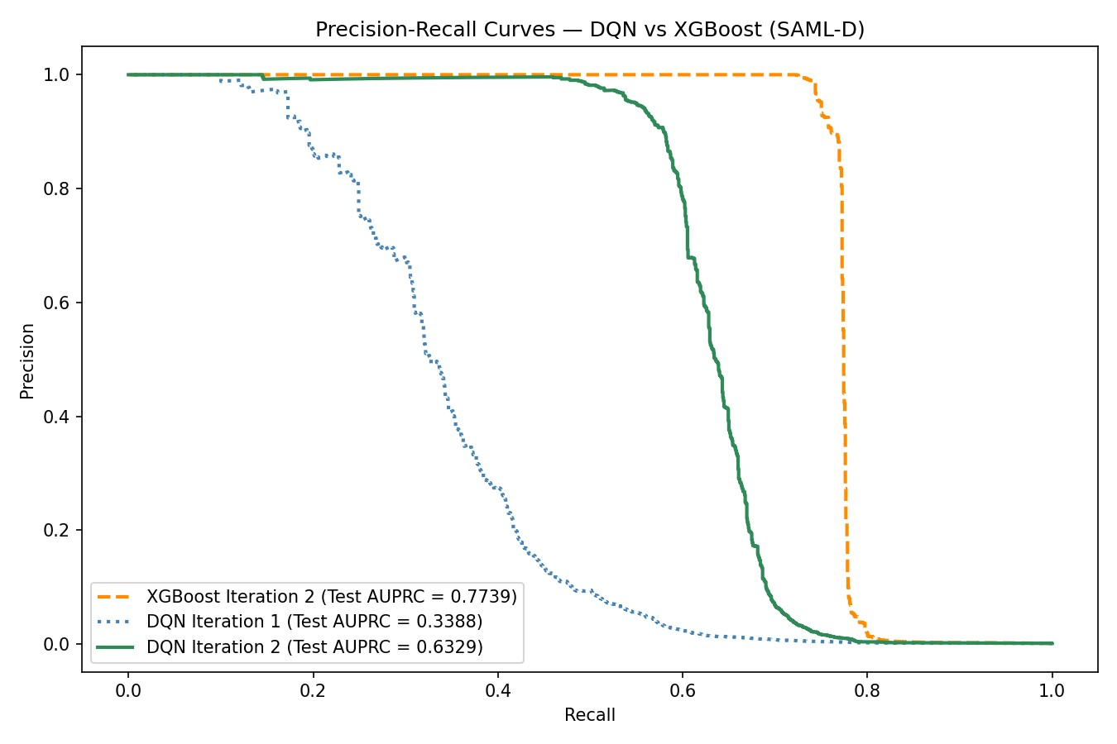
Figure 2: AUPRC curves for all trained models (XGBoost iteration 1 and 2 are identical)

Explainability
SHAP analysis was applied to both the XGBoost Iteration 2 model and the DQN Iteration 2 model, using a fixed sample of 10,000 test transactions (random state=42) to ensure reproducibility and comparability across models.
XGBoost SHAP analysis. Figure 3 shows the global feature importance for the XGBoost model.
Two features dominate the model’s decisions: receiver unique senders (32.1%) and sender unique receivers (22.1%), together accounting for over half of all model impact. receiver tx count follows at 11.4%. These three features alone account for 65.6% of the model’s decisions, indicating that XGBoost primarily detects suspicious behaviour through the diversity and volume of an account’s transaction network rather than individual transaction properties such as amount or payment type. This aligns with the layering stage of money laundering, where criminals deliberately spread funds across many accounts to obscure their origin.
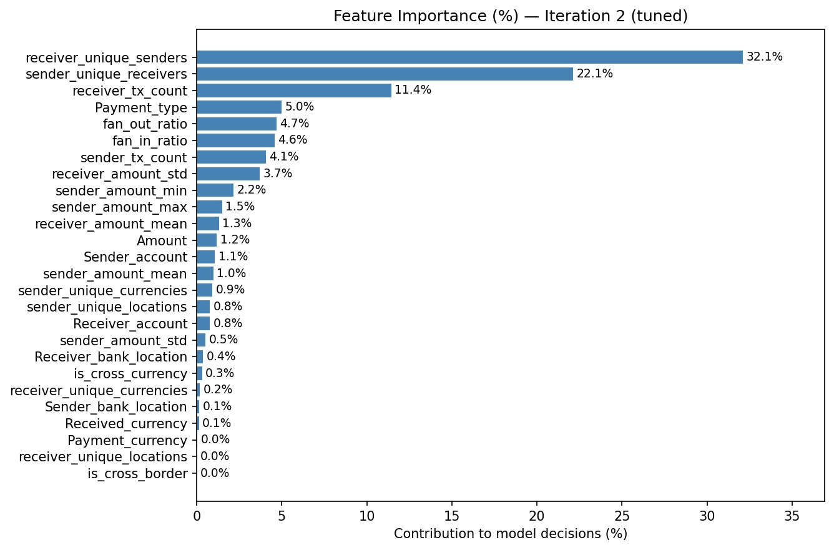
Figure 3: XGBoost iteration 2 feature importance SHAP values in percentage
DQN SHAP analysis. Figure 4 shows the global feature importance for the DQN across 10,000 test transactions. Similar to XGBoost, receiver unique senders is the sole dominant feature at 19.7%, confirming that the number of unique senders to a receiver account is the strongest signal for both models. However, the DQN’s importance is more spread out across features compared to XGBoost, where two features alone accounted for over 54% of model impact. The DQN’s second and third most important features are sender amount min (8.8%) and sender amount std (7.2%), indicating the DQN pays more attention to the variability and minimum value of a sender’s transaction amounts. Notably, the DQN’s feature set includes one-hot encoded payment type columns such as
Payment type Debit card and Payment type Cash Deposit, which appear individually in the ranking since the DQN required numeric input, whereas XGBoost handled Payment type as a single categorical feature.
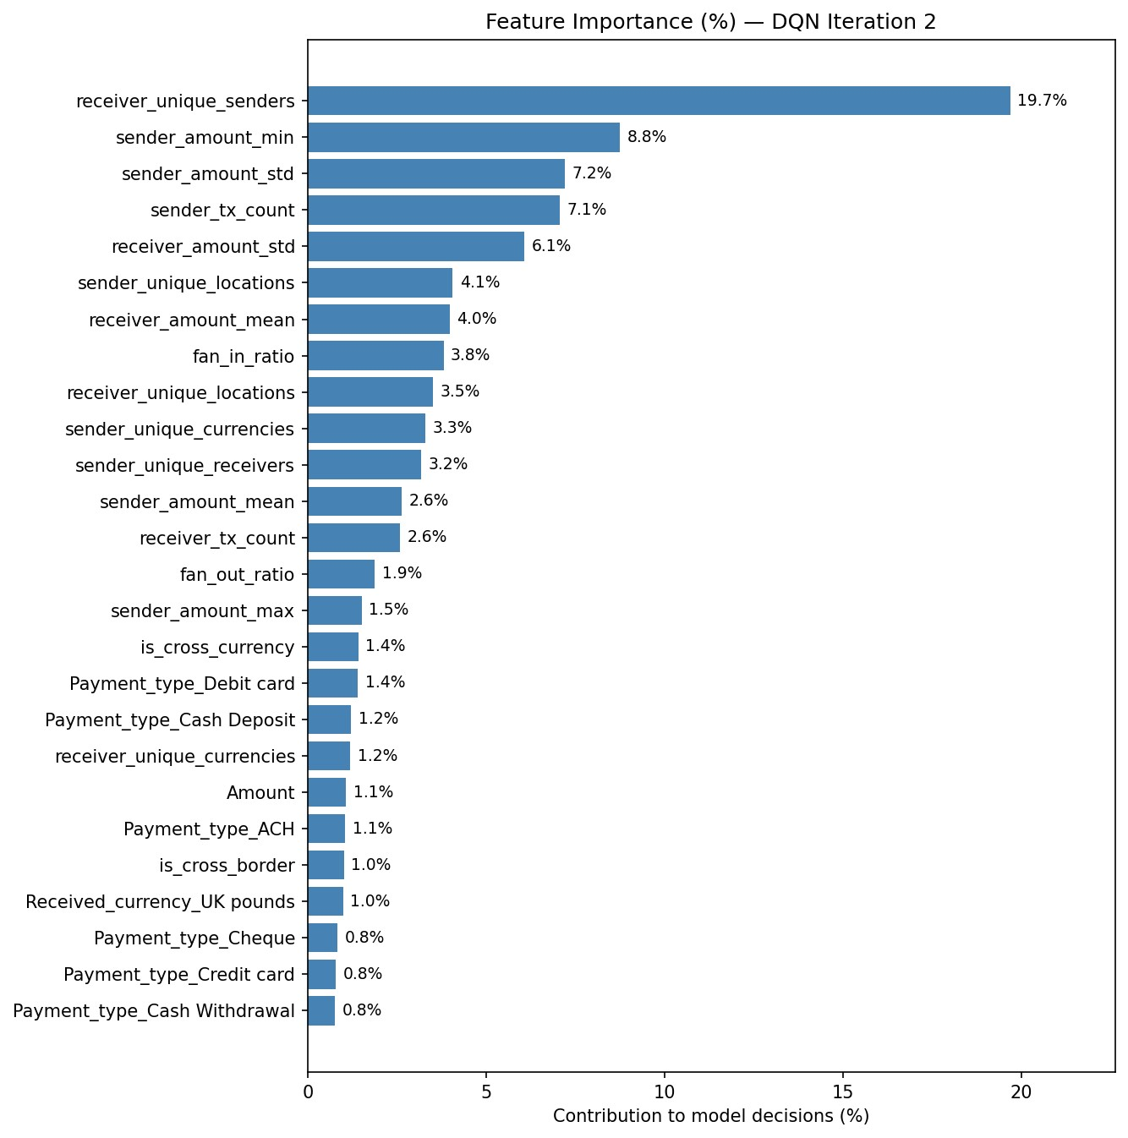
Figure 4: DQN iteration 2 feature importance SHAP values in percentage
Individual transaction explanations. Both models produce per-transaction SHAP explanations to satisfy the Wwft explainability requirement (Art. 16.2e) Ministerie van Financi¨en (2008). Each plot shows which features pushed the model towards (pink) or away from (blue) a suspicious classification, providing investigators with a ranked and interpretable explanation for each alert. This is consistent with the operational practice at ABN AMRO, where every alert is accompanied by the top three contributing features Menon and Nguyen (2026).
Figure 5 shows a laundering transaction correctly flagged by XGBoost with a suspicion score of 1.0. The dominant signal is receiver unique senders = 22 (+54.6%), meaning the receiver account received money from 22 different senders, a strong fan-in pattern. sender unique receivers = 4 and Payment type = Cash Withdrawal both contribute an additional 15% each, together painting a clear picture of suspicious network behaviour combined with a high-risk payment method.
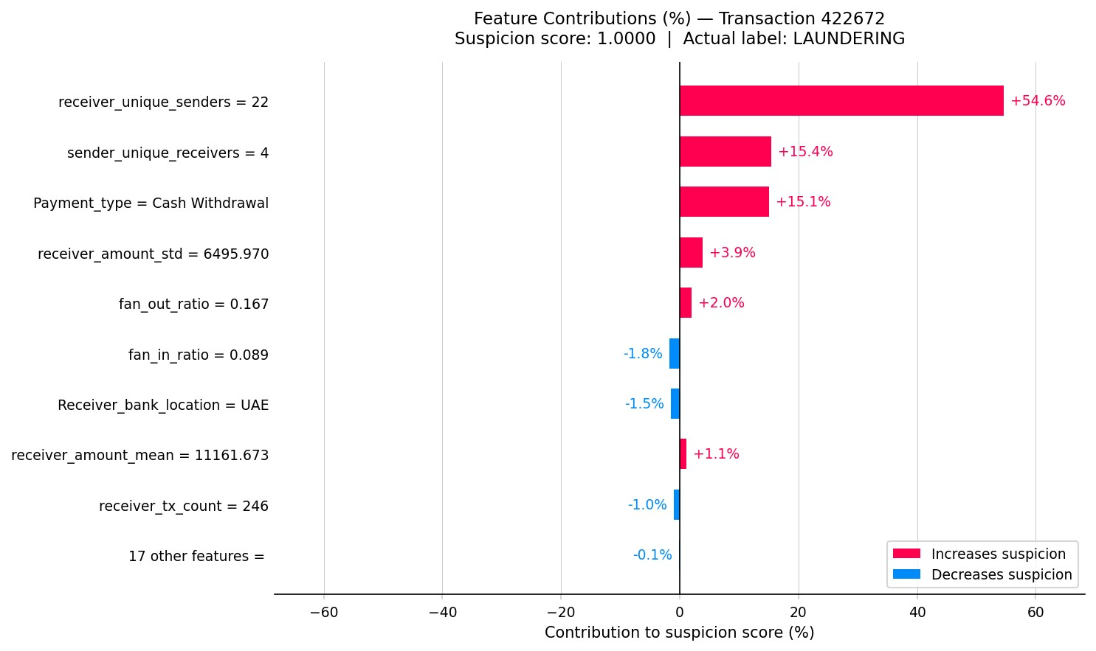
Figure 5: XGBoost feature contributions for a correctly flagged laundering transaction (suspicion score:
1.0)
Figure 6 shows a laundering transaction correctly flagged by the DQN with a suspicion score of
0.8859. The strongest signal is Payment type Cash Deposit (+24.0%), followed by sender unique receivers (+8.1%) and sender amount min (+7.3%). Unlike XGBoost, the DQN places significant weight on the payment type itself rather than purely on network diversity, reflecting the partially different decision strategy observed in the global SHAP analysis.
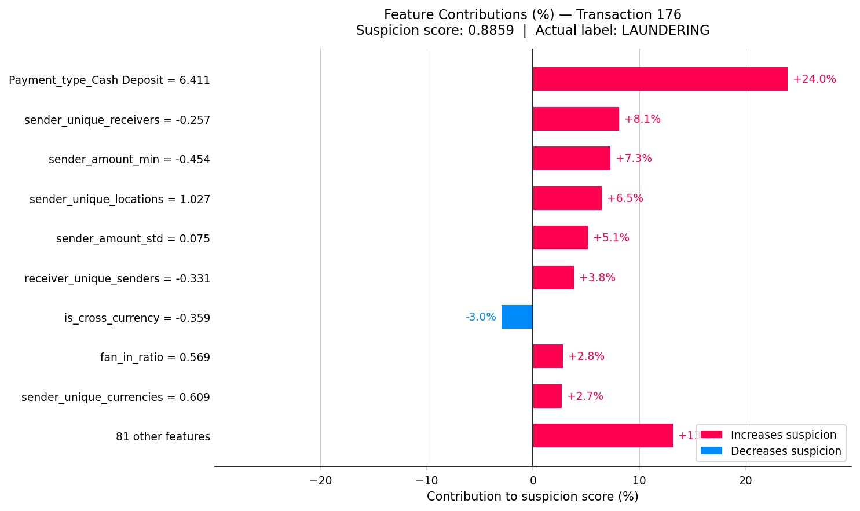
Figure 6: DQN feature contributions for a correctly flagged laundering transaction (suspicion score: 0.8859)
Figure 7 shows a normal transaction correctly cleared by XGBoost with a suspicion score of 0.0. The dominant signal pulling the score down is receiver unique senders = 1 (-47.2%), meaning the receiver account has only ever received money from a single sender, the opposite of a fan-in pattern. receiver amount std, receiver tx count, and Payment type = ACH all contribute further negative signals, collectively building a strong case for legitimacy.
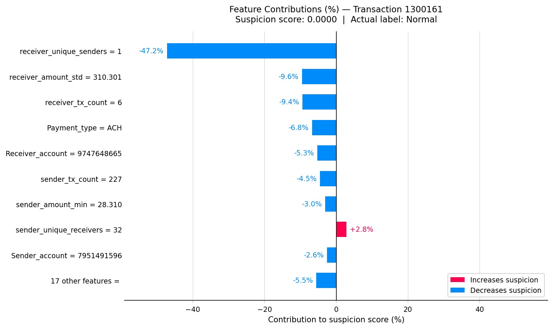
Figure 7: XGBoost feature contributions for a correctly cleared normal transaction (suspicion score: 0.0)
Figure 8 shows a normal transaction scored by the DQN with a suspicion score of 0.4506. While the transaction is ultimately classified as normal, the score is notably higher than the XGBoost equivalent, indicating the DQN is less confident in its normal classification. The dominant negative signal is again receiver unique senders (-33.4%), but several features such as sender amount min (+19.0%) and sender tx count (+6.1%) push the score upward, creating more uncertainty. This illustrates the DQN’s tendency to produce less decisive scores on normal transactions compared to XGBoost.
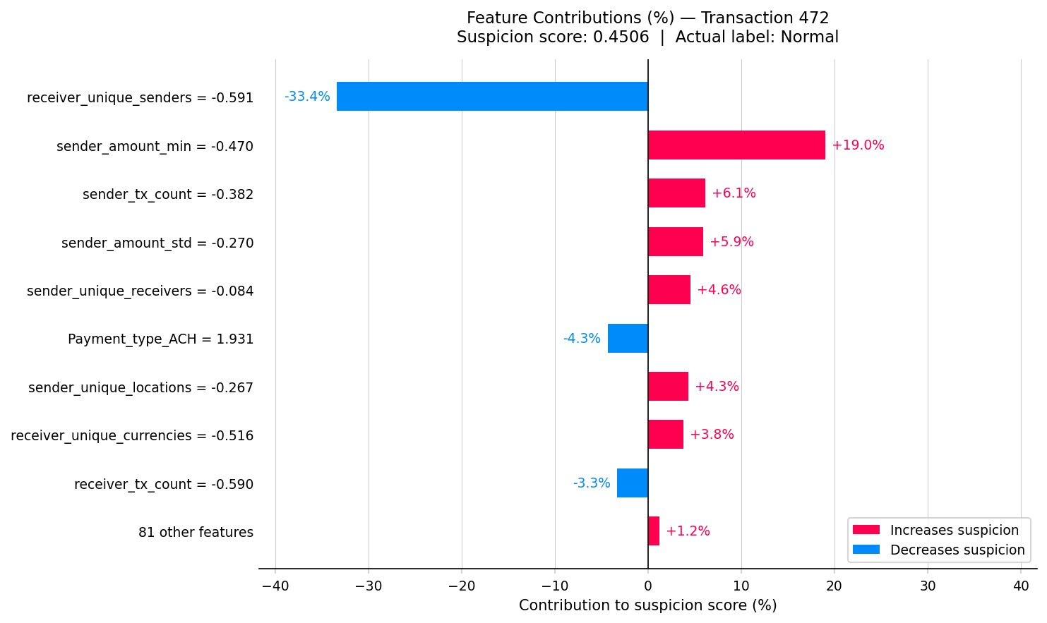
Figure 8: DQN feature contributions for a correctly cleared normal transaction (suspicion score: 0.4506)
Per-pattern SHAP analysis. The Laundering type column, retained in the test set for posthoc analysis, was used to assess whether model performance and feature attribution differ across the 17 suspicious typologies in SAML-D. [PLACEHOLDER: insert per-pattern breakdown here once analysis is complete]

Model Complexity
Table 17 compares the structural complexity of both models.
Table 17: Model complexity comparison
Criterion | XGBoost | DQN
Architecture | Gradient boosted trees | 4-layer neural network
Learnable parameters | 35 trees with gbtree booster | 90×124 + 124×62 + 62×31 +  31×15 + 15×2 = 19,339
Hyperparameter sensitivity | Moderate (sensitive to learning rate and subsample rate, but defaults land in a well-performing  region for this dataset) | High (sensitive to epsilon decay, reward function, batch size)
Training procedure | Single-pass gradient boosting | Multi-epoch RL with experience replay and target network
Explainability | SHAP values | SHAP values (the required onehot-encoding makes the SHAP values less interpretable than the  XGBoost SHAP values)
XGBoost is structurally simpler from a configuration standpoint, achieving strong performance with default hyperparameters. The DQN, while having a relatively small number of learnable parameters, requires substantially more design decisions, including the reward function, epsilon schedule, replay buffer, and target network update frequency, each of which can significantly affect performance.

Resource Demand
Table 18 compares the computational cost of training both models.
Table 18: Resource demand comparison
Criterion | XGBoost | DQN
Iteration 1 training time | 12 seconds | ∼10 minutes (10 epochs)
Iteration 2 training time | ∼46 minutes (150 combi-  nations) | ∼27 minutes (34 epochs)
Hardware | CPU / GPU | GPU
Grid search feasibility | Feasible due to histogrambased algorithm | Feasible but extremely time-consuming at ∼27 minutes per run, therefore not performed
XGBoost’s histogram-based training algorithm (tree method=hist) was specifically designed to handle large datasets efficiently Chen and Guestrin (2016), allowing a single model to train in approximately 12 seconds on 6.6 million transactions. This speed made a 150-combination grid search feasible at a total cost of 46 minutes. The DQN, by contrast, processes transactions episode by episode and required approximately 10 minutes for Iteration 1 and 27 minutes for Iteration 2, with the faster per-epoch time in Iteration 2 likely attributable to the larger batch size of 256 compared to 20 in Iteration 1, improving GPU utilisation. A full grid search for the DQN would require running dozens of configurations at this cost each, making it infeasible within the scope of this research.

Stakeholder Evaluation Results
NO STAKEHOLDER EVALUATION HAS TAKEN PLACE YET process of how testing went and the feedback received? idk please help me on this one.

Discussion
HALLO! DIT IS NOG DE DISCUSSIE SECTIE VAN MIJN PVA MAAR IK HEB ERG VEEL SLAAP DUS IK DOE DIT WEL NA DE 70% VERSIE. IK NEEM AAN DAT ALS IK DISCUSSIE EN CONCLUSIE OPEN LAAT, DE WIKI NOG MOET UPDATEN EN HET PROTOTYPE EN STAKEHOLDER EVALUATIE ENZO DAT DAT WEL TE DOEN IS VOOR 12 JUNI. en dan zorg ik er eventueel voor dat de onderdelen die ik maak na de 70% versie dat ik daar apart feedback voor vraag zodat ik niet inlever zonder feedback?
This chapter outlines the anticipated limitations, risks, and safeguards that are relevant to the validity and reliability of this research.

Anticipated Limitations
Several limitations are anticipated that may affect the findings of this research.
Synthetic dataset. The SAML-D dataset is synthetic, meaning the results may not fully translate to real banking environments. Patterns present in real transaction data may differ from those encoded in the dataset’s.
Single dataset. This research evaluates both models on a single dataset. Results may therefore be specific to the characteristics of SAML-D and may not hold across different datasets or banking contexts.
DQN reward function design. The performance of a DQN is highly sensitive to the design of the reward function. A poorly designed reward may lead to suboptimal behaviour, such as the agent learning to avoid flagging transactions altogether to minimise penalties. Designing a reward function that accurately reflects the cost of false positives and false negatives in an AML context is a non-trivial challenge.
Explainability of DQN. While SHAP values will be applied post-hoc to interpret the DQN’s decisions, it is not guaranteed that these explanations will be as reliable or consistent as those produced by XGBoost, which does not require additional explainability methods as its decision-making process is transparent by design.

Risk Analysis
The following risks are identified that could affect the successful completion of this research.
DQN convergence. Deep Q-Networks can be difficult to train and may fail to converge, particularly on highly imbalanced datasets. If the DQN fails to learn a meaningful policy, the comparison with XGBoost would not be informative. This risk is mitigated by closely following the architecture and hyperparameters used by Qayoom et al. Qayoom et al. (2024) as a starting point.
Computational resources. Training a DQN on 9.5 million transactions may require significant computational resources. If training time becomes prohibitive, a smaller subset of the SAML-D dataset may be used, which could affect the generalizability of the results.
Class imbalance impact. The extreme class imbalance of 0.104% may make it difficult for both models to learn meaningful patterns. If neither model achieves satisfactory performance, the results may be inconclusive. This risk is mitigated by using AUPRC as the evaluation metric and applying threshold-based classification. If the imbalance proves too extreme during experimentation, the SAMLD data generator Oztas et al. (2023) can be used to generate additional laundering cases, reducing the imbalance to a more manageable ratio.
Stakeholder availability. The stakeholder evaluation with DLL depends on the availability of relevant personnel. If this evaluation cannot be conducted, several fallback options are available. As a first alternative, the evaluation will be conducted with a domain expert who has over 13 years of experience at ABN AMRO and holds an AML certification, providing equivalent industry expertise. If this is also not feasible, the evaluation will be conducted with a data scientist familiar with AML systems. In the worst case, the explainability analysis will be limited to a theoretical assessment based on the SHAP outputs alone.

Planned Validity and Reliability Safeguards
The following measures are planned to ensure the validity and reliability of the research findings.
Reproducibility. All experiments will be conducted with a fixed random seed to ensure that results can be reproduced.
Fair comparison. Both models will be trained and evaluated on the same dataset, using the same chronological 70/15/15 train/validation/test split and the same evaluation metric.
Transparent reporting. Both positive and negative results will be reported honestly. If XGBoost outperforms the DQN, this will be reported and interpreted rather than dismissed.
Literature alignment. All methodological choices are grounded in the existing literature and industry practice, as documented throughout this thesis. This ensures that the research design is defensible and comparable to prior work.

Conclusion
This chapter summarises the research objective, the planned deliverables, and the milestones that structure the execution of this research.

Clear Objective
This research investigates whether Reinforcement Learning can effectively detect money laundering and how it compares to leading supervised learning methods on tabular banking transaction data. To answer this, a Deep Q-Network is implemented and benchmarked against XGBoost, the current industry and academic standard, on the SAML-D dataset. The research additionally addresses the explainability requirement imposed by the Wwft by incorporating SHAP-based explanations into the proposed model.

Deliverables
This research produces the following deliverables:
- A trained XGBoost baseline model evaluated on the SAML-D dataset.
- A trained Deep Q-Network model evaluated on the same dataset under identical conditions.
- A quantitative performance comparison between both models using AUPRC.
- SHAP-based explanations for flagged transactions produced by both models.
- A stakeholder testing report based on feedback from DLL.
- A thesis document, serving as the full research report.

Realistic Planning and Milestones
The research is planned according to the following milestones:
Table 19: Planning and Milestones
Date | Milestone
23 March 2026 | Ethics Peer Review presentation
1 April 2026 | Progress meeting Block 3 and feedback processing
11 May 2026 | 70% version
4 May 2026 | Progress meeting Block 4
13 May 2026 | Feedback processing Block 4
12 June 2026 | 100% version

References
Alarab, I., Prakoonwit, S., and Nacer, M. I. (2020). Competence of graph convolutional networks for anti-money laundering in bitcoin blockchain. In Proceedings of the 2020 5th International Conference on Machine Learning Technologies, page 23–27. Association for Computing Machinery. https: //doi.org/10.1145/3409073.3409080.
Altman, E. (2019). IBM transactions for anti money laundering (AML). https://www.kaggle.com/ datasets/ealtman2019/ibm-transactions-for-anti-money-laundering-aml.
Attard, M. and de Bruijn, L. (2026). Machine learning binnen ING. Guest lecture at Hogeschool van Amsterdam. Personal notes taken during presentation.
Bryansky, S., Tony, krivoship, CPMP, and Giba (2019). 2nd solution, CPMP view. https://www.kaggle.com/competitions/ieee-fraud-detection/writeups/ 2-uncles-and-3-puppies-2nd-solution-cpmp-view.
Chen, T. and Guestrin, C. (2016). Xgboost: A scalable tree boosting system. In Proceedings of the 22nd ACM SIGKDD International Conference on Knowledge Discovery and Data Mining, pages 785–794. https://doi.org/10.1145/2939672.2939785.
Cox, D. (2012). What is money laundering? In Handbook of Anti Money Laundering, chapter 1, pages 5–13. John Wiley Sons, Ltd. https://doi.org/10.1002/9780470685280.ch1.
Cui, Y., Han, X., Chen, J., Zhang, X., Yang, J., and Zhang, X. (2025). FraudGNN-RL: A graph neural network with reinforcement learning for adaptive financial fraud detection. IEEE Open Journal of the Computer Society, 6:426–437. https://doi.org/10.1109/OJCS.2025.3543450.
Deotte, C. and Yakovlev, K. (2019). 1st place solution - part 2. https://www.kaggle.com/ competitions/ieee-fraud-detection/writeups/fraudsquad-1st-place-solution-part-2.
European Parliament and Council of the European Union (2016). Regulation (EU) 2016/679 — general data protection regulation (GDPR). https://www.privacy-regulation.eu/nl/ artikel-9-verwerking-van-bijzondere-categorieen-van-persoonsgegevens-EU-AVG.htm.
Financial Crimes Enforcement Network (FinCEN) (n.d.). What is money laundering? Retrieved March 12, 2026, from https://www.fincen.gov/what-money-laundering.
FIU-the Netherlands (2023). What is money laundering? Retrieved March 12, 2026, from https: //www.fiu-nederland.nl/en/home/what-is-money-laundering/.
Harris, D. A., Pyndiura, K. L., Sturrock, S. L., and Christensen, R. A. (2021). Using real-world transaction data to identify money laundering: Leveraging traditional regression and machine learning techniques. STEM Fellowship Journal, 7(1):1–11. https://doi.org/10.17975/sfj-2021-006.
IEEE Computational Intelligence Society (2019). IEEE-CIS fraud detection: Improve fraud prevention accuracy. Kaggle. https://www.kaggle.com/competitions/ieee-fraud-detection/overview.
Jensen, R. I. T., Ferwerda, J., Jørgensen, K. S., Jensen, E. R., Borg, M., Krogh, M. P., Jensen, J. B., and Iosifidis, A. (2023). A synthetic data set to benchmark anti-money laundering methods. Scientific Data, 10. https://doi.org/10.1038/s41597-023-02569-2.
Lin, E., Chen, Q., and Qi, X. (2019). Deep reinforcement learning for imbalanced classification. https://arxiv.org/abs/1901.01379.
Mahootiha, M. (2023). money laundering data. https://www.kaggle.com/datasets/maryam1212/ money-laundering-data.
Menon, S. and Nguyen, T. (2026). AML at ABN AMRO. Guest lecture at Hogeschool van Amsterdam. Personal notes taken during presentation.
Ministerie van Financi¨en (2008). Wet ter voorkoming van witwassen en financieren van terrorisme (Wwft). Retrieved March 14, 2026, from https://wetten.overheid.nl/BWBR0024282/ 2026-01-01#Hoofdstuk3.
Mnih, V., Kavukcuoglu, K., Silver, D., Rusu, A. A., Veness, J., Bellemare, M. G., Graves, A., Riedmiller, M., Fidjeland, A. K., Ostrovski, G., Petersen, S., Beattie, C., Sadik, A., Antonoglou, I., King, H., Kumaran, D., Wierstra, D., Legg, S., and Hassabis, D. (2015). Human-level control through deep reinforcement learning. Nature, 518(7540):529–533. https://doi.org/10.1038/nature14236.
Oztas, B., Cetinkaya, D., Adedoyin, F., Budka, M., Dogan, H., and Aksu, G. (2023). Enhancing anti-money laundering: Development of a synthetic transaction monitoring dataset. In 2023 IEEE International Conference on e-Business Engineering (ICEBE), pages 47–54. https://doi.org/10. 1109/ICEBE59045.2023.00028.
Probst, P., Boulesteix, A.-L., and Bischl, B. (2019). Tunability: Importance of hyperparameters of machine learning algorithms. Journal of Machine Learning Research, 20:1–32. http://jmlr.org/ papers/v20/18-444.html.
Qayoom, A., Khuhro, M., Kumar, K., Waqas, M., Saeed, U., ur Rehman, S., Wu, Y., and Wang, S. (2024). A novel approach for credit card fraud transaction detection using deep reinforcement learning scheme. PeerJ Computer Science, 10:e1998. https://doi.org/10.7717/peerj-cs.1998.
Team Lions (2019). 5th place solution: Lions. https://www.kaggle.com/competitions/ ieee-fraud-detection/writeups/lions-5th-place-solution-lions.
Tertychnyi, P., Godgildieva, M., Dumas, M., and Ollikainen, M. (2022). Time-aware and interpretable predictive monitoring system for anti-money laundering. Machine Learning with Applications, 8:100306. https://doi.org/10.1016/j.mlwa.2022.100306.
Vimal, S., Kayathwal, K., Wadhwa, H., and Dhama, G. (2021). Application of deep reinforcement learning to payment fraud. https://arxiv.org/abs/2112.04236.
Weber, M., Chen, J., Suzumura, T., Pareja, A., Ma, T., Kanezashi, H., Kaler, T., Leiserson, C. E., and Schardl, T. B. (2018). Scalable graph learning for anti-money laundering: A first look. https:
//arxiv.org/abs/1812.00076.
Weber, M., Domeniconi, G., Chen, J., Weidele, D. K. I., Bellei, C., Robinson, T., and Leiserson, C. E. (2019). Anti-money laundering in bitcoin: Experimenting with graph convolutional networks for financial forensics. https://arxiv.org/abs/1908.02591.
XGBoost Developers (2024). XGBoost parameters. Retrieved May 2026, from https://xgboost. readthedocs.io/en/stable/parameter.html.
Youssef, B., Bouchra, F., and Brahim, O. (2023). State of the art literature on anti-money laundering using machine learning and deep learning techniques. In The 3rd International Conference on Artificial Intelligence and Computer Vision (AICV2023), March 5–7, 2023, pages 77–90. Springer Nature Switzerland. https://rdcu.be/e8mZQ.
Zhinin-Vera, L., Chang, O., Valencia-Ramos, R., and Velastegui, R. (2020). Q-credit card fraud detector for imbalanced classification using reinforcement learning. In Proceedings of the 12th International Conference on Agents and Artificial Intelligence (ICAART). SCITEPRESS. https:
//www.scitepress.org/Papers/2020/91561/91561.pdf.

